Computer Networks Lab Task – 2
Instructor: Ma’am Hurmat Hidayat
Roll No: 20P-0563
Name: Mahad Ashraf
Section: B

Task 1: Cisco packet Tracer
1-Step: First we open Cisco packet tracer after that we click on End Devices and select two end devices
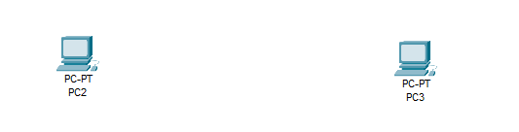
We can also name these pc’s

2 – Step:
Now you click on first pc a settings will pop up on that you will see on top right corner there is option called desktop click on that
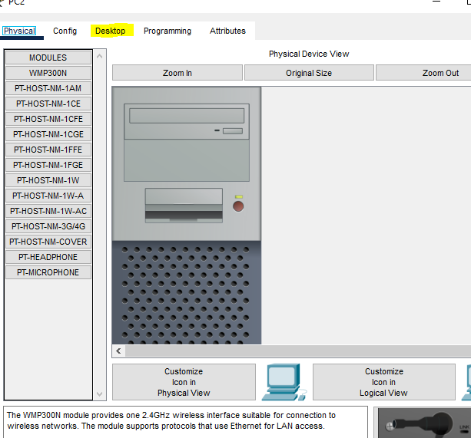
After that select IP configuration
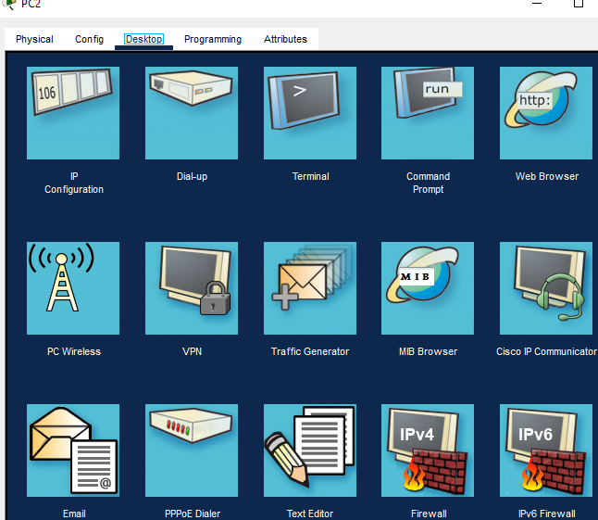
Now type in the IP addresses and subnet mask
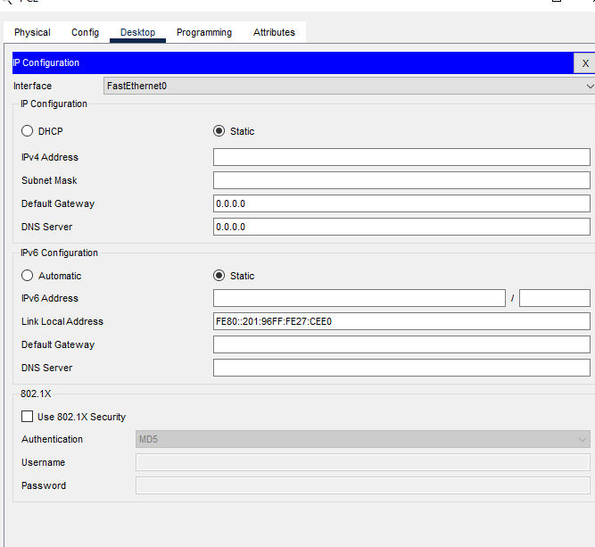
Follow the same procedure for pc 2

3 – Step:
Now after doing this on bottom left corner you will see an lighting icon click on that set of different wires will appear you have to select the lining one wire
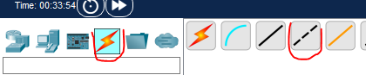

4 –Step :
Now you have to connect both of these pc’s with each other by selecting Fast Ethernet Cable
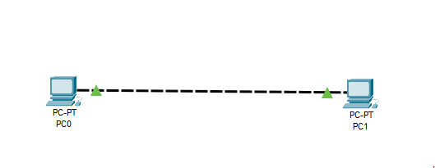

5 – Step:
Now in the last step you have to ping pc 1 with the 2 pc for that click on 1 pc and go on desktop over there click on command prompt, After clicking on that type in ping and write the IP address of the 2 pc and press enter and if the procedure works both the pc’s are connected together
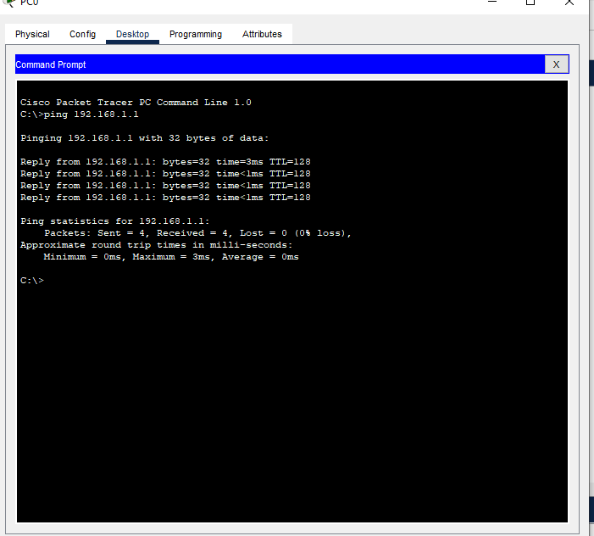

Part 2: Configure PC1 as follow: IPv4: 192.168.1.1 Subnet mask: 255.255.255.0
And PC2 as: IPv4: 192.168.2.1 Subnet mask: 255.255.255.0

1-Step: First we open Cisco packet tracer after that we click on End Devices and select two end devices
2 – Step:
Now you click on first pc a settings will pop up on that you will see on top right corner there is option called desktop click on that
After that select IP configuration
Now type in the IP address for first pc 192.168.1.1 and subnet mask 255.255.255.0
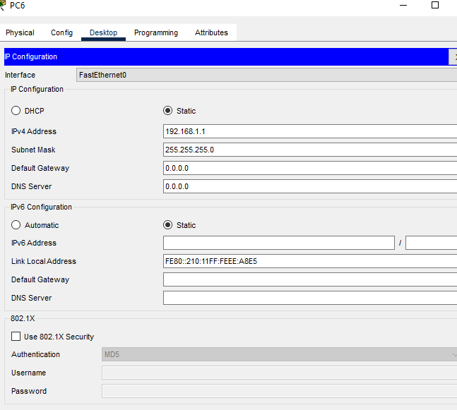
And for pc 2 type IP address 192.168.2.1 and subnet mask 255.255.255.0
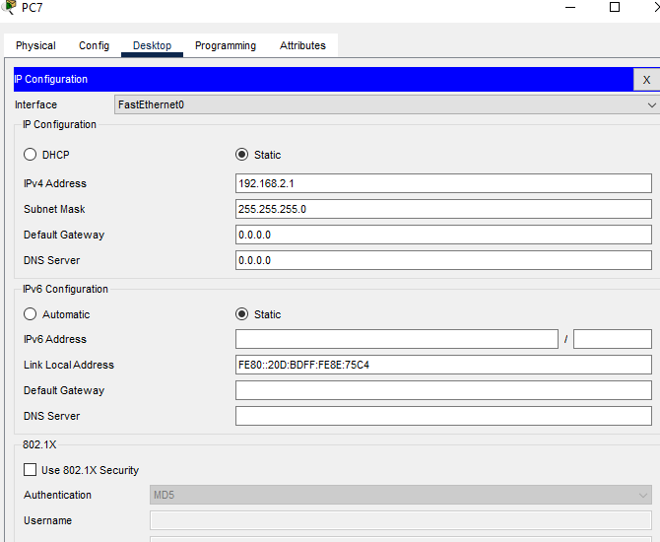

3 – Step:
Now after doing this on bottom left corner you will see an lighting icon click on that set of different wires will appear you have to select the lining one wire

4 –Step :
Now you have to connect both of these pc’s with each other by selecting Fast Ethernet Cable

5 – Step:
Now in the last step you have to ping pc 1 with the 2 pc for that click on 1 pc and go on desktop over there click on command prompt, After clicking on that type in ping and write the IP address of the 2 pc and press enter we will get a request time out error in this one
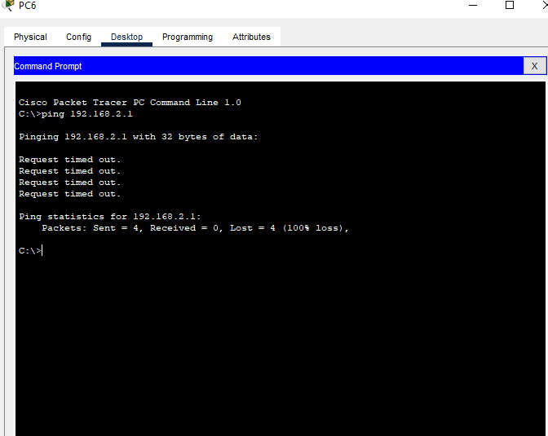

Part 3: Configure PC1 as follow: IPv4: 192.168.1.1 Subnet mask: 255.255.0.0
And PC2 as: IPv4: 192.168.2.1 Subnet mask: 255.255.0.0

We again click on pc 1 and select IP address and type in the new subnet mask for pc 1
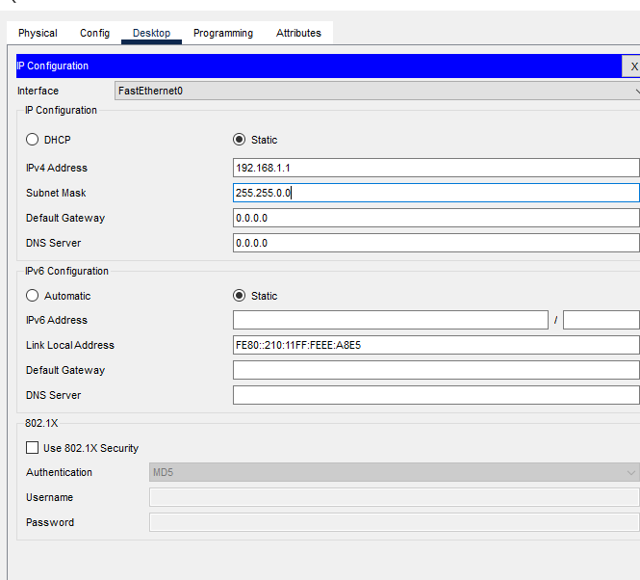
And after that we click on pc 2 and do the same and type in new subnet mask for pc 2
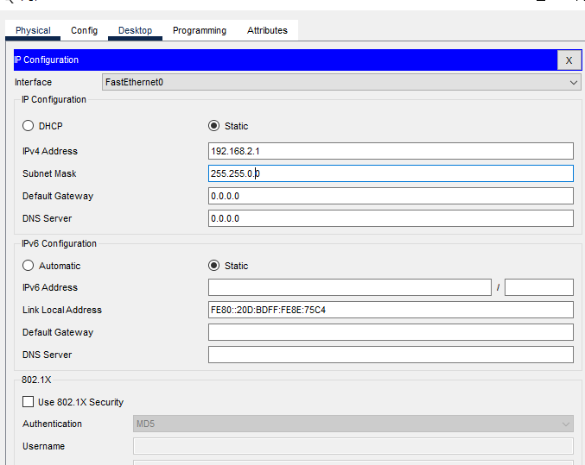

Now we open command prompt and ping these 2 pc’s and we get a reply from the 2 pc packet sent 4 and no lost it also showed the round trip
